ASSIGNMENT 1 COMP_SCI-5530-0001

STUDENT ID: 16336824

Visualization 1:

Pie Chart describing Gender distribution

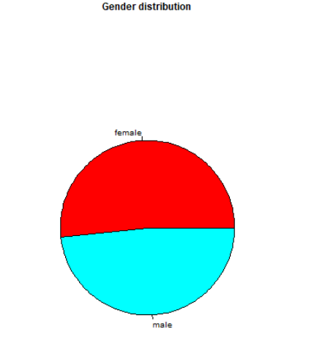

Visualization 2:

This Image has Distribution of Math and Reading Scores

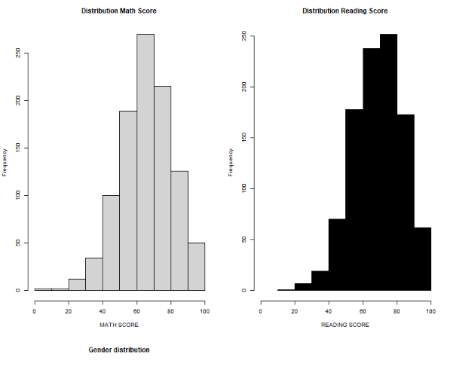

Visualization 3:

This graph shows the boxplots of writing score Vs Gender

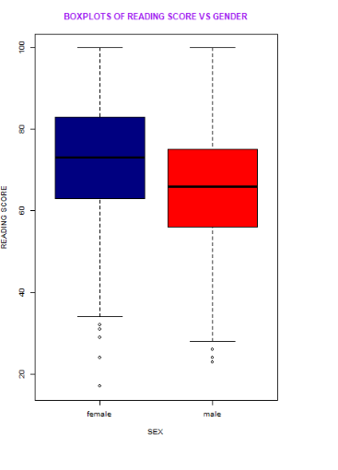

Visualization 4:

The below image shows the Distribution of groups

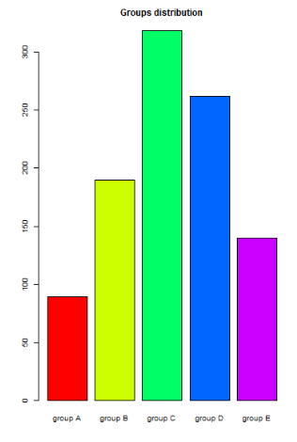

Visualization 5:

The histogram below shows Math Scores by Race/Ethinicity

